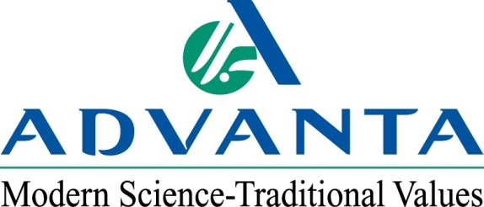

FOR IMMEDIATE RELEASE CONTACT: Steve Ligon, Advanta US – (214) 596-8335
May 8, 2013 Adam Buckallew,
Duff Dynamic Marketing – (816) 891-8845

Tim Jacobsen Joins Advanta US as Western Region Sales Manager

AMARILLO, Texas – Advanta US, a leading international supplier of proprietary agricultural crop genetics and seed, has hired Tim Jacobsen as its western region sales manager. Jacobsen will manage sales of both private label seed and the Alta Seeds brand west of the Rocky Mountains. His other responsibilities will include technical and agronomic support, product training, test plot supervision and business development.

“Tim has a strong background of working with farmers in the western states, and especially California,” says Steve Ligon, NAFTA business director for Advanta US. “His combination of experience as an agronomist, educator and salesman makes him an excellent addition to our team.”

Jacobsen has more than 30 years of agricultural experience in agronomy, product development, research and sales. His previous work has included positions with companies such as Syngenta, Resource Seeds, Inc., Horizon Ag Products, and Crop Care Services. Jacobsen has also worked as an educator and researcher at California State University – Fresno. Most recently he served as a district sales manager for Sorghum Partners.

Jacobsen earned a master of science degree in plant science from California State University – Fresno and a bachelor of science in agricultural soil science from California State Polytechnic University in San Luis Obispo.

For more information on Advanta US and its products, visit: www.advantaus.com.

###

About Advanta
Advanta US is an operating unit of Advanta, an India-based global seed business that combines the most advanced techniques in conventional plant breeding with biotechnology to deliver world-class seed and solutions to its customers around the world. Advanta is a member of the UPL group of companies.

