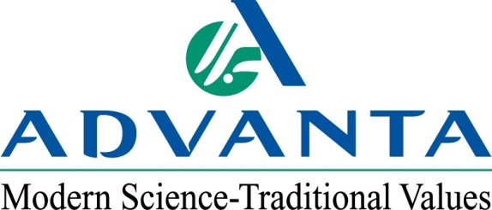

FOR IMMEDIATE RELEASE CONTACT: Steve Ligon, Advanta US – (214) 596-8335
April 2, 2013 Adam Buckallew,
Duff Dynamic Marketing – (816) 891-8845

Advanta US Names Ruben Dicun Head of Business Development

AMARILLO, Texas – Advanta US, a leading international supplier of proprietary agricultural crop genetics and seed, has named Ruben Dicun, head of business development. Dicun will be responsible for risk management, branding, and new business opportunities related to products and markets for the NAFTA region.

“Ruben has a long and successful track record with Advanta and we welcome him to our management team,” says Steve Ligon, NAFTA business director for advanta US. “He will play a key role in our strategic business development as we continue to grow as a company.”

With 18 years of experience in various roles, Dicun has been with Advanta and its legacy companies since 1995. Prior to joining the Advanta US team, he served as chief financial officer for the Latin American Region based in Argentina, where he managed strategic finance, legal, and information systems among other duties. Dicun has been actively involved in several mergers and acquisitions, primarily in Argentina and Brazil, playing an important role in the growth of Advanta. He has held managerial positions in marketing and customer service throughout his career.

Dicun has degrees in accounting and business administration from the University of Buenos Aires School of Management. His educational background includes postgraduate degrees in Food and Agribusiness at University of Buenos Aires, Educational Science at the University of La Plata and participation in the Wharton Executive Program at the University of Pennsylvania and IMD in Switzerland, among others.

For more information on Advanta US and its products, visit: www.advantaus.com.

###

About Advanta
Advanta US is an operating unit of Advanta, an India-based global seed business that combines the most advanced techniques in conventional plant breeding with biotechnology to deliver world-class seed and solutions to its customers around the world. Advanta is a member of the UPL group of companies.

