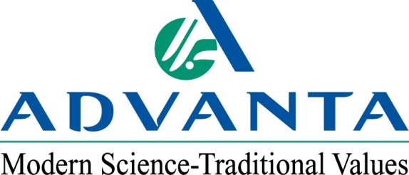

FOR IMMEDIATE RELEASE CONTACT: Steve Ligon, Advanta US – (214) 596-8335
October 25, 2012 Adam Buckallew,
Duff Dynamic Marketing – (816) 891-8845

Brannon Byers Named Global Sorghum Supply Chain Manager for Advanta

HEREFORD, Texas – Advanta US, a leading supplier of proprietary agricultural crop genetics and seed is pleased to announce Brannon Byers has been named global crop supply chain manager for sorghum for parent company Advanta. He will work with Advanta sorghum operations in Argentina, Australia, Brazil, Indonesia, India, Thailand, Ukraine and the USA to coordinate production plans. In addition to his new responsibilities, Byers will retain his role as supply chain manager for Advanta US.

“Brannon is an excellent addition to our global crop management team and we are confident he will optimize product development cycles and create innovative supply chain solutions to support our business strategies,” says Steve Ligon, NAFTA business director for Advanta US. “A well-coordinated global sorghum production plan will lead to more cost-efficient and flexible ways to serve our customers.”

As the global crop supply chain manager for sorghum, Byers will be responsible for new and existing hybrid seed production, inventory management for hybrid and parent seed, production diversification, budgeting and global logistics.

Byers has served as supply chain manager for Advanta US for six years. He is a graduate of Texas Tech University with a degree in economics.

For more information on Advanta US and its products, visit: www.advantaus.com.

###

About Advanta
Advanta is an India-based global seed business that combines proprietary crop genetics and plant breeding capabilities with biotechnology to produce high quality seed products and solutions for its customers around the world. Advanta is a member of the UPL group of companies.

